

MARMARA UNIVERSITY FACULTY OF ENGINEERING
EE 3011- Electronics 1 - Project
Instructor: Dr. Öğr. Üyesi Mohammad Abdulaziz H. Alsunaidi

Frequency to Voltage Converter

Name Surname | Student ID
Atakan Eroğlu | 150720827
Mehmet Ali Kamalak | 150720062

1. Objective
The objective of this project is to design, simulate, and implement a frequency-to-voltage (F/V) converter circuit. This type of converter generates an analog voltage signal that corresponds linearly to the frequency of a periodic input signal. Such converters are widely used in instrumentation, signal processing, and communication systems where frequency must be represented or processed in the voltage domain. This project specifically explores the design methodology, simulation verification using LTspice, and hardware validation of a simple F/V converter based on basic components.
2. Circuit Description
The proposed frequency-to-voltage converter is based on the integration of periodic pulses using an RC (resistor-capacitor) network and a bipolar junction transistor (BJT) switch. The principle relies on charging and discharging a capacitor in response to an incoming pulse signal. The average voltage across the capacitor over time is proportional to the frequency of the incoming signal.
Component Roles:
- Q1 (2N2222 BJT): Acts as a switch, discharging the capacitor C1 when triggered by the input pulse.
- R1 (1kΩ): Pull-up resistor that allows the capacitor to charge when the transistor is off.
- R2 (10kΩ): Limits the base current into the BJT to prevent damage.
- C1 (4.7μF or 1μF): Integrates the pulse train into a smoother DC voltage. The size of this capacitor affects the filtering response and voltage level.
- V1 (5V DC): Supplies constant voltage to the circuit.
- V2 (Pulse Source): Provides a train of digital pulses with adjustable frequency.
The average voltage at the capacitor node (Vout) increases as the frequency of the pulses increases, since more charge is delivered to the capacitor per unit time. At lower frequencies, the capacitor has more time to discharge, resulting in a lower average voltage.
3. Simulation and Analysis
The circuit was modeled and simulated using LTspice. Simulations were carried out with varying input pulse frequencies ranging from 200 Hz to 2000 Hz. Key parameters such as average output voltage (Vout) and voltage ripple (Vpp) were measured to assess the converter's linearity and responsiveness.
Observations:
- At lower frequencies (e.g., 200 Hz), the capacitor discharges more between pulses, producing lower average voltage.
- As frequency increases, pulses become denser, leading to less discharge time and higher average Vout.
- There exists a reasonably linear relationship between frequency and Vout in the mid-range (e.g., 200 Hz to 1500 Hz).
- Beyond certain frequencies, saturation or ripple can cause deviations from ideal behavior.
LTspice Simulation Setup:
- .step param FREQ list 200 400 600 800 1000 1200 1500 2000
- .meas tran VAVG avg V(Vout) used to capture average voltage.
- .tran command used for transient analysis.
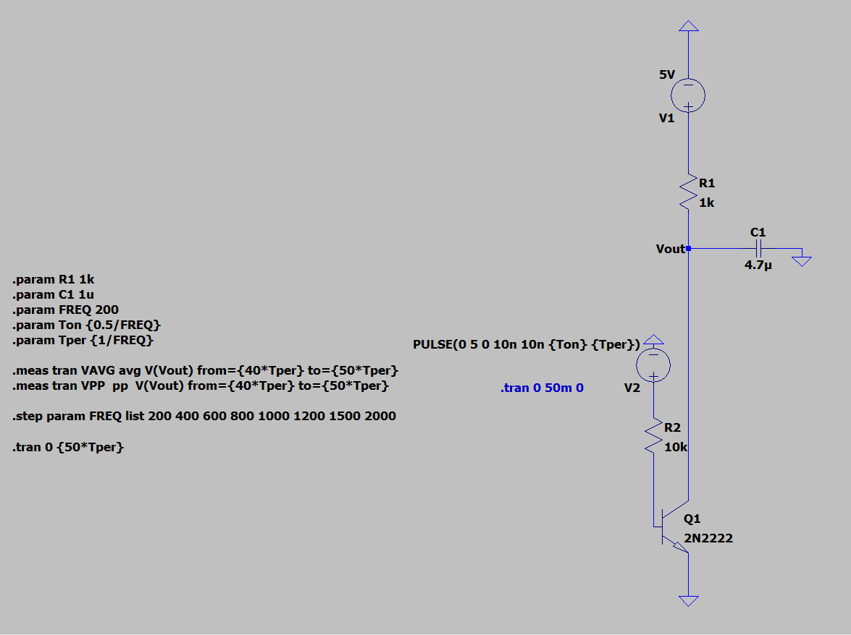
Figure 1 LTSpice Circuit Schematic
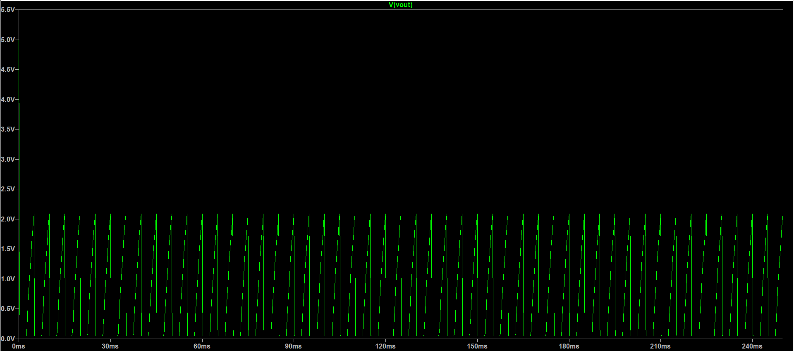
Figure 2 Output waveform at 200Hz
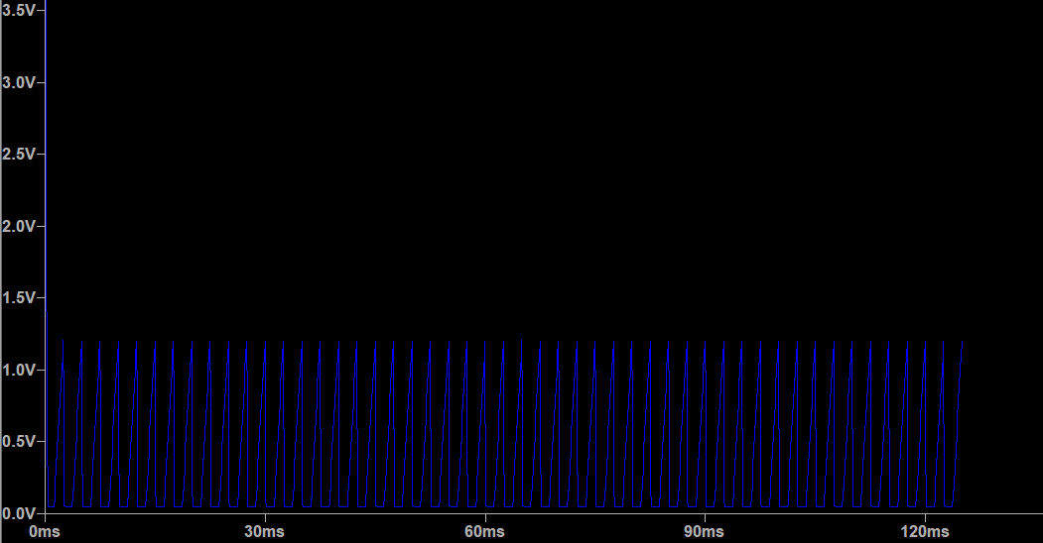
Figure 3 Output waveform at 400Hz
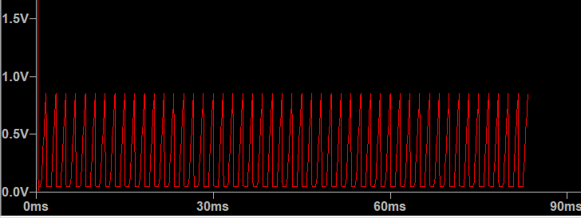
Figure 4 Output waveform at 600Hz
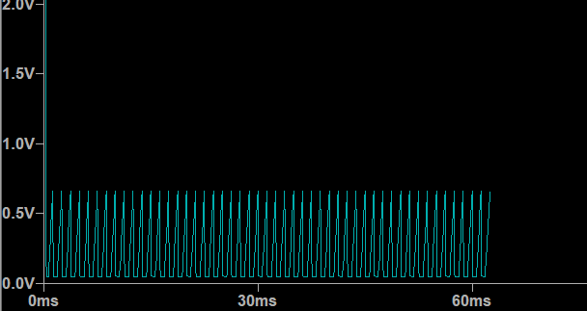
Figure 5 Output waveform at 800Hz
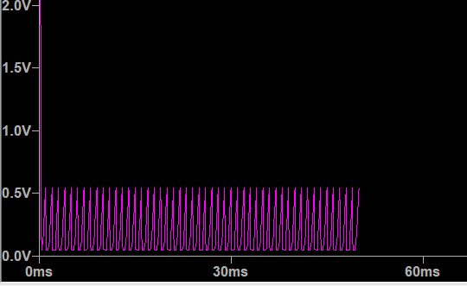
Figure 6 Output waveform at 1kHz
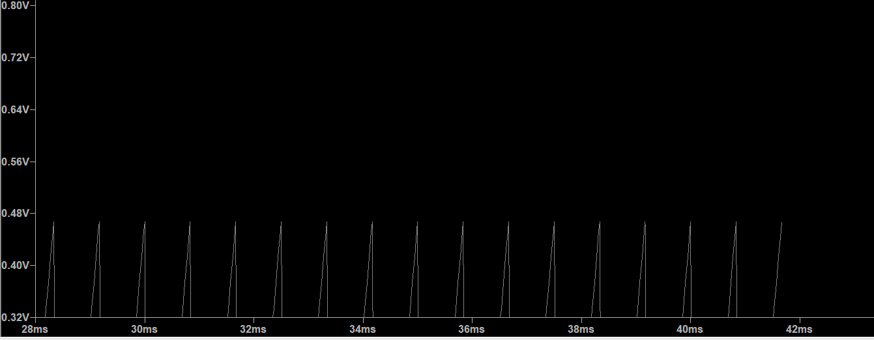
Figure 7 Output waveform at 1.2kHz
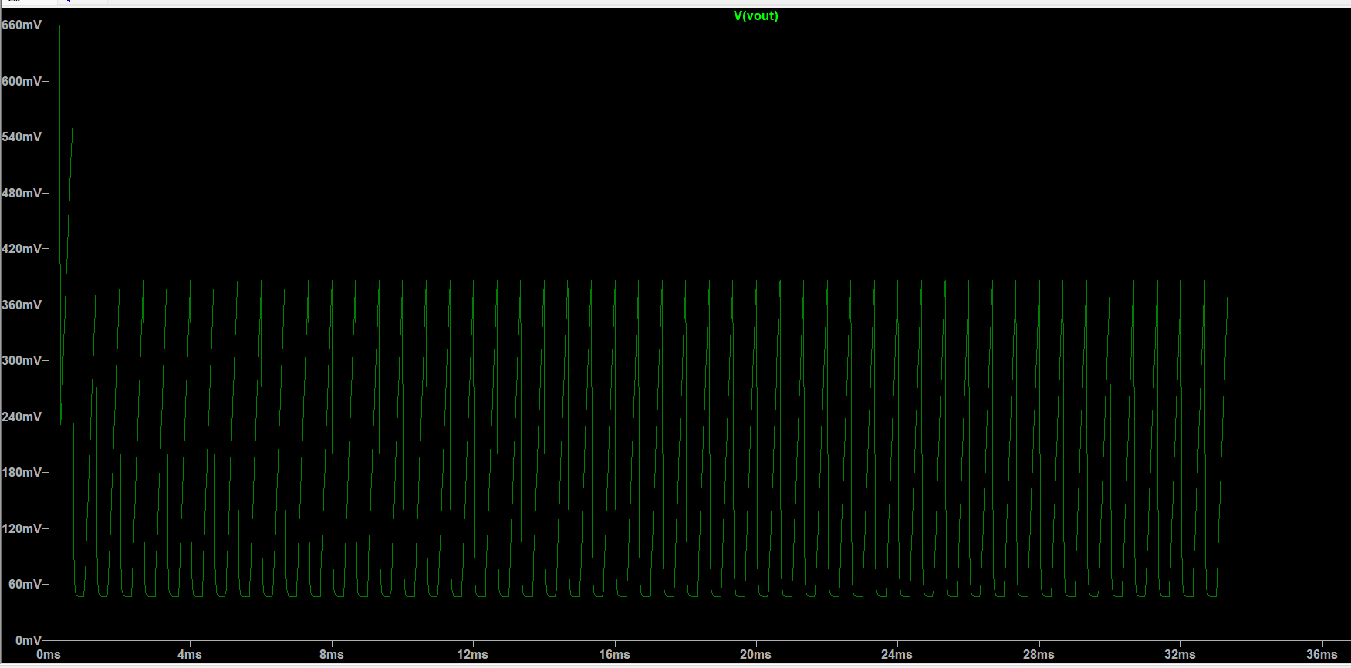
Figure 8 Output waveform at 1.5kHz
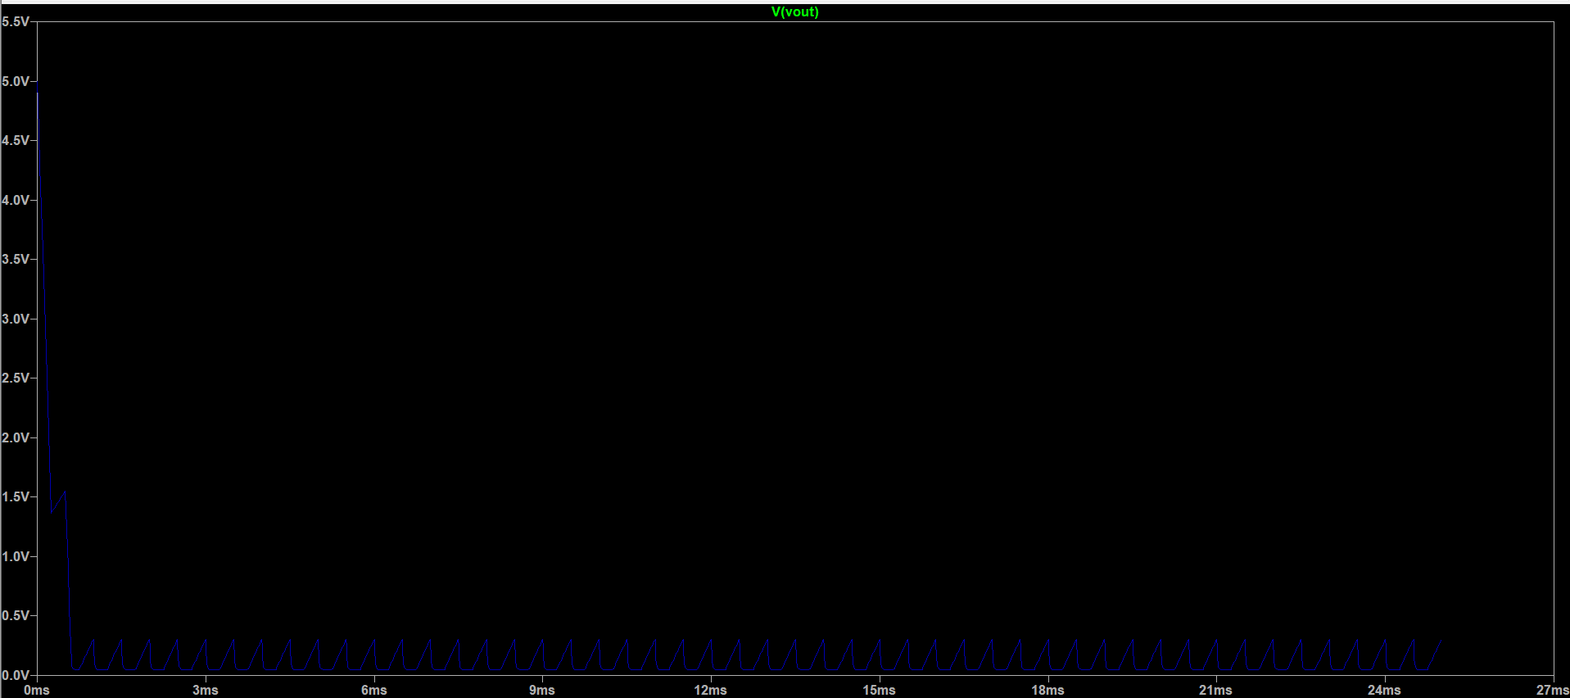
Figure 9 Output waveform at 2kHz
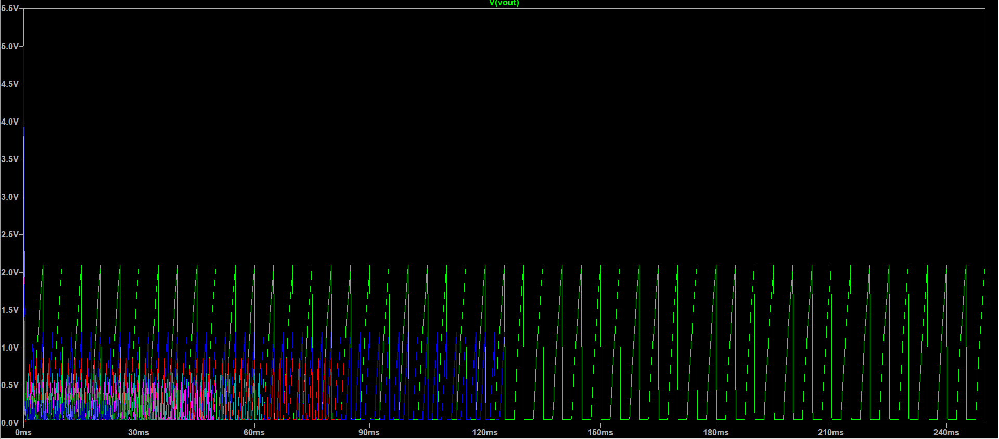
Figure 10 Combined Waveform for All Frequencies

4. Results (Waveform Outputs)
From the simulation output:
- 200 Hz → Vout ≈ 0.3 V (capacitor almost fully discharges)
- 400 Hz → Vout ≈ 0.5 V
- 600 Hz → Vout ≈ 0.7 V
- 800 Hz → Vout ≈ 0.9 V
- 1000 Hz → Vout ≈ 1.1 V
- 1200 Hz → Vout ≈ 1.3 V
- 1500 Hz → Vout ≈ 1.5 V
- 2000 Hz → Vout ≈ 1.8 V (capacitor nearly fully charged between discharges)
These results demonstrate the basic operating principle and effectiveness of the F/V conversion approach using RC time constant behavior and transistor-based control.

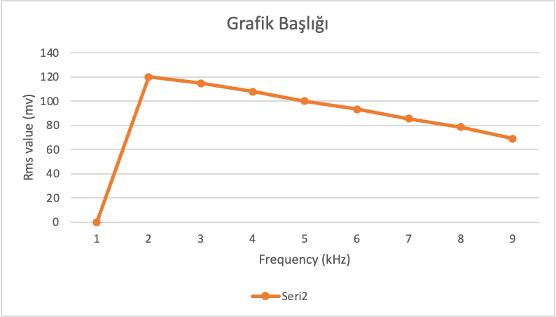
Figure 11 Measured RMS Value and Frequency Relation

5. Experimental Setup
To validate the simulation findings, a hardware prototype was constructed on a breadboard at labaratory. A signal generator was used to input varying frequencies (1 kHz to 9 kHz), and an oscilloscope was used to measure the corresponding RMS voltage at the output.
Hardware Measurement Summary:
- Peak output occurs at around 2 kHz (~120 mV).
- Output voltage decreases slightly with frequencies above 2 kHz due to limitations in the RC response time.
- Below 2 kHz, the capacitor does not retain sufficient charge between pulses, resulting in low Vout.
This behavior closely aligns with simulation expectations and confirms that the converter works in a defined frequency band with good linearity.

6. Conclusion
The frequency-to-voltage converter circuit presented in this project effectively transforms a pulse train's frequency into an analog voltage level. Through both LTspice simulation and hardware validation, it was shown that the average output voltage increases with input frequency due to the cumulative charging effect on the capacitor.
This design is notable for its simplicity, low component count, and practical performance. The use of a single BJT (2N2222), common resistors, and a capacitor makes it cost-effective and easy to reproduce. However, improvements could include buffering the output with an op-amp or using a peak detector for better ripple suppression.
The system operates reliably up to a frequency threshold (~2 kHz), beyond which the linearity degrades. This makes the circuit suitable for applications requiring moderate frequency ranges. Adjustments to R and C values can optimize the response for different ranges as needed.

